Database Design Idea  #1: Arts & Music Festival Database

Each year, an event-planning company is commissioned to organize a large-scale arts, music and entertainment festival. The festival is hosted at a central location/venue near a regional transport hub, and lasts for approx. 3 days. There are several main stages at the festival venue that serve as the focal point for acts. Each stage hosts many artists, yet a stage is not constrained to one musical genre. An artist, which may include solo musicians or bands, perform sets, which can be defined as the collection of songs/pieces that an artist will play during one performance, on several stages across various days and/or times. Many other non-musical artists also perform at the festival, such as comedians, poets, and creative performers. These types of artists perform in tents. There are several tents set up at the venue. Each tent reflects a genre, so that artists and performers of similar tastes, perform in a certain tent. Tents, therefore, are divided up into the following genres: comedy, poetry & literature reading, relaxation and massage, DJ, beer-drinking, and creative arts (e.g body & face painting). Attendees of the festival take multiple forms; adult, student, family, child. ~~Each attendee purchases a ticket type corresponding to their grouping. Note that a family ticket covers 2 adults and 2 children. Further, a ticket may be purchased for the full 3-day event as a day ticket or day+night ticket; one day ticket, two-day ticket with or without overnight stay, and three-day ticket with or without camping.~~ For those festival-goers who plan on attending for two- or three-days with overnight stay, they must purchase a camping ticket. ~~Attendees may choose from different types of camping: campervan, luxury tipee (similar to ‘glamping’), and bring-your-own tents.~~ Campsites are divided into two areas across the venue: one for families only, and the other for all other kinds of festival-goers. Finally, the festival is managed and maintained over the course of its three days, by several distinct types of employees; medical aids, security staff, assistants to provide directions and information.

Possible Entities:

* Stage
* Tent (Relaxation, DJ, Beer-drinking, Comedy, Poetry)
* Artist (Musician, comedian, poet, other creative performers)
* Employee (Medic, Security, Information/Info assistants)
* Campsite
* Set
* Musical Genre (Rock, punk, metal, pop, indie)
* (Ticket)
* (Facilities/Services – toilets, showers, food stalls?)

Entity Attributes:

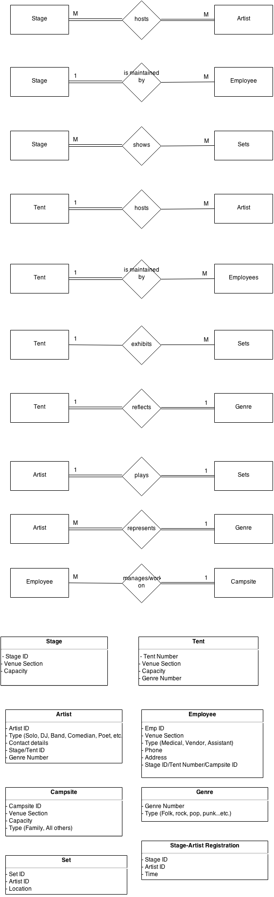



Database Project Idea #2: Travel Planning Agency/Visa Specialist Database

A visa specialist agency requires a database to manage its operations and keep track of its clientbase The agency processes various types of visas (e.g. working holiday, business, student visas etc.) to students and non-students to live and/or work in several destinations around the world. Each client is only eligible for one type of visa. The client is categorized according to his her status, which is further determined by education, income level, reason for obtaining a visa or purpose of visa, and also by country. In addition arranging an appointment for their clients with the relevant Embassy, the agency will book flights, either one-way or return, for the client to/from the destination country. It is important to note that each client is assigned a sales rep/agent from the company. One agent will handle many accounts at the same time, however. The agency also offer travel insurance to clients. ~~Finally, the agency maintain a listing of jobs for third-level students, when recruiters from various countries advertise for summer positions.~~

Possible entities:

* Visa
* Client
* Destination
* Embassy
* Flight
* Accommodation
* Sales representative
* Insurance
* (Reservation)

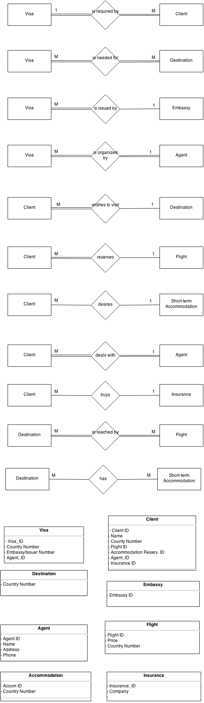



Database Design #3: Cruise Ship Company

A cruise ship company that provides holiday cruise packages to its customers requires a database to maintain its customer reservation system. The company offers several holiday packages to its customers, based on the destination or world region (e.g. South-East Asian Adventure, Mediterranean Madness), and the time of year. Importantly, a package is specific to the current season and year e.g. Carribean Cruisin’ Summer 2014, Carribean Cruisin’ Autum 2014, Asian Adventure Spring 2015. Therefore, a package will only ever have one ship. Conversely, a ship, over its career, will be part of many packages. Necessarily, each package is peculiar to one route, and a route will be contained in only one package. A route has many ships that service it over time, but a ship will only ever travel one route. Further, a ship’s route or schedule will involve many ports over its journey. One port can be included in many routes – for example, some routes will have the initial departure from the same city, and then take different courses. A package also defines the type of membership type or class that the customer will be throughout their onboard adventure. Membership types include platinum, gold, silver, bronze and determine the various services/assets onboard that the customer will have access to. One package has many membership types available, and these very membership types are applicable to all packages. Membership type also determines the room type allocated for a customer, such that the more lucrative the package, the more luxury afforded in comfort (e.g. Gold Membership entitles the customer to a Deluxe Double Room with Balcony, etc.). A membership type is applicable to many rooms onboard the cruise liner, but a room only has one declaration of membership type (e.g. room 304 on European Express cruise is reserved for those with Platinum membership). Of course, ships have many rooms, but a room is specific to one ship. Finally, a customer can choose one package, but that same package can be chosen by many customers. A single customer can make one reservations (e.g. A family would have one booking ID; the same ID for every family member), and a reservation pertains to a single customer, where a reservation can be operationally defined as an instance of a package (which is specific to route and time of year, as above) and thus, a package will have many bookings (to be filled up). Finally, a reservation involves many rooms (e.g. in the case of families or large group bookings), but one room is involved in a single booking.

Entity List:

* Package
* Ship
* Route
* Port
* Booking
* Passenger
* Membership
* Room